# Managing Data Project 1.2

Charlie Mei cm3947

**QUESTION 1**

The code below begins with the code I submitted for Project 1.1. This is used as the beginning point to create new tables and update existing ones.

SEE APPENDIX A for the code.

**QUESTION 2**

The employee table now has two additional columns – one for the status of the employee and one for their discount. In this structure, the discount attribute depends on the employee status, so functional dependency is ensured. When a new employee is added and their status set, then their discount can be then be added.

**QUESTION 3**

The database is not in 3NF because there exists a functional dependency in the employee table that creates an insertion anomaly.

**QUESTION 4**

See APPENDIX B for the code.

**QUESTION 5**

The functional dependency no longer holds in the database. No attributes in the employee table depend on another attribute in the relation. When a new employee is added to the database, only the employee status is updated in the employee relation, and the corresponding discount is can be found in the status relation.

**QUESTION 6**

CREATE VIEW emp_discount AS

SELECT E.name, E.depname, S.s_ssn, St.discount

FROM employee AS E, supervisor AS S, status AS St

WHERE E.ssn = S.ssn AND E.title = St.title;

SELECT * FROM emp_discount;

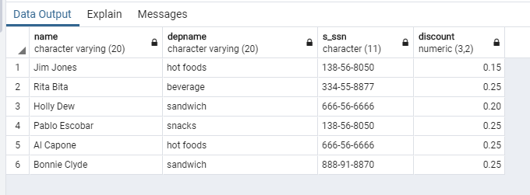

**QUESTION 7**

/* Use "emp_discount" to write a query which outputs for each department,

and the average discount for all members of the department. */

SELECT depname, avg(discount) AS avgDepDiscount

FROM emp_discount

GROUP BY depname;

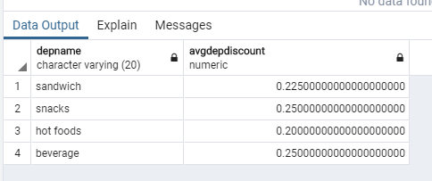

**APPENDIX**

1. **QUESTION 1 CODE**

/* ========== PROJECT 1.1 ORIGINAL DATABASE SCHEMA ========== */

/* Department table - list of all departments and their names */

CREATE TABLE department (

did char(2) UNIQUE, /* An ID number for each department */

depname varchar(20) PRIMARY KEY /* Unique department */

);

INSERT INTO department (did, depname)

VALUES

('D1', 'hot foods'),

('D2', 'sandwich'),

('D3', 'snacks'),

('D4', 'beverage');

SELECT * FROM department;

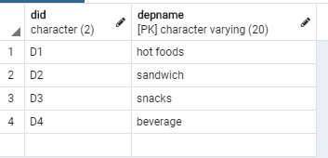

/* Employee table - list of employees, department they work in */

CREATE TABLE employee (

ssn char(11) PRIMARY KEY,

name varchar(20) NOT NULL,

salary numeric(8, 2),

sdate date /* Employee hire date */,

depname varchar(20),

FOREIGN KEY (depname) REFERENCES department

);

INSERT INTO employee (ssn, name, salary, sdate, depname)

VALUES

('134-56-8877', 'Jim Jones', 28000, '01-26-2015', 'hot foods'),

('138-56-8050', 'Rita Bita', 32000, '02-15-2017', 'beverage'),

('334-55-8877', 'Holly Dew', 29000, '01-15-2016', 'sandwich'),

('666-56-6666', 'Pablo Escobar', 48000, '01-26-2014', 'snacks'),

('888-91-8870', 'Al Capone', 40000, '01-26-2015', 'hot foods'),

('111-22-3333', 'Bonnie Clyde', 42000, '04-07-2015', 'sandwich');

SELECT * FROM employee;

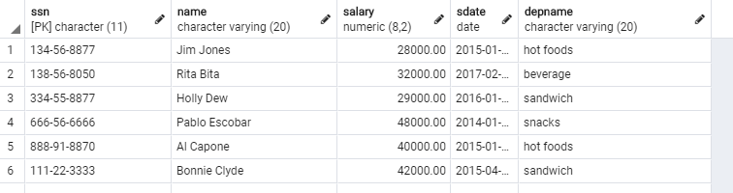

/* Manager table - mapping of managers to their apointment date */

CREATE TABLE manager (

m_ssn char(11) PRIMARY KEY, /* Manager SSN */

apdate date, /* Date of manager appointment to department */

FOREIGN KEY (m_ssn) REFERENCES employee(ssn)

);

INSERT INTO manager (m_ssn, apdate)

VALUES

('138-56-8050', '03-18-2018'),

('666-56-6666', '05-05-2015'),

('888-91-8870', '01-01-2016'),

('111-22-3333', '01-01-2016');

SELECT * FROM manager;

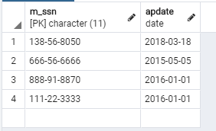

/* Supervisor table - mapping of supervisor to supervisee */

CREATE TABLE supervisor (

ssn char(11) NOT NULL PRIMARY KEY,

s_ssn char(11) NOT NULL,

FOREIGN KEY (ssn) REFERENCES employee,

FOREIGN KEY (s_ssn) REFERENCES employee(ssn)

);

INSERT INTO supervisor (ssn, s_ssn)

VALUES

('134-56-8877', '138-56-8050'),

('138-56-8050', '334-55-8877'),

('334-55-8877', '666-56-6666'),

('666-56-6666', '138-56-8050'),

('888-91-8870', '666-56-6666'),

('111-22-3333', '888-91-8870');

SELECT * FROM supervisor;

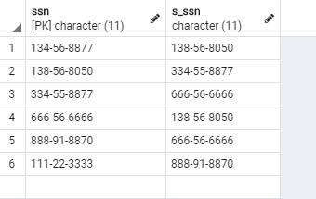

/* ========== PROJECT 1.2 ========== */

/* MODIFICATION OF THE DATABASE TO REFLECT NEW BUSINESS RULE */

/* Add employee status (employee, supervisor and/or manager) and discount amount as additional attributes in employee table */

/* Employee table - list of employees, department they work in */

ALTER TABLE employee ADD title varchar(20);

ALTER TABLE employee ADD discount decimal(5, 4);

UPDATE employee SET title = 'Employee', discount = 0.15 WHERE ssn = '134-56-8877';

UPDATE employee SET title = 'Manager', discount = 0.25 WHERE ssn = '138-56-8050';

UPDATE employee SET title = 'Supervisor', discount = 0.2 WHERE ssn = '334-55-8877';

UPDATE employee SET title = 'Manager', discount = 0.25 WHERE ssn = '666-56-6666';

UPDATE employee SET title = 'Manager', discount = 0.25 WHERE ssn = '888-91-8870';

UPDATE employee SET title = 'Manager', discount = 0.25 WHERE ssn = '111-22-3333';

SELECT * FROM employee;

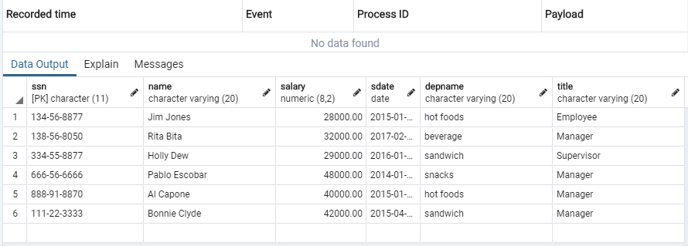

1. **Question 4 code**

/* MODIFICATION TO 3NF */

/* Status table - list of all employee types and their associated discount amounts */

CREATE TABLE status (

title varchar(20) PRIMARY KEY, /* One of employee, supervisor, manager. */

/* It is assumed that all employees will take use of the highest discount available to them

i.e. an employee that is a manager and a supervisor will be listed as a manager

to take account of the higher 25% discount */

discount decimal(5, 4) /* Employee 15%, supervisor 20%, manager 25% */

);

INSERT INTO status (title, discount)

VALUES

('Manager', 0.25),

('Supervisor', 0.2),

('Employee', 0.15);

SELECT * FROM status;

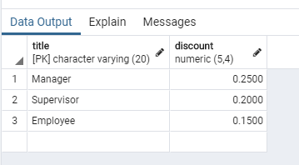

/* Update employee table to include just title - remove discount attribute */

ALTER TABLE employee

DROP COLUMN discount;

SELECT * FROM employee;

/* Replace original manager table with depmanager table */

DROP TABLE manager CASCADE;

/* depmanager table - mapping of department to manager */

CREATE TABLE depmanager (

/* Update employee table to include title */

DROP TABLE employee CASCADE;

/* Employee table - list of employees, department they work in */

CREATE TABLE employee (

ssn char(11) PRIMARY KEY,

name varchar(20) NOT NULL,

salary decimal(8, 2),

sdate date /* Employee hire date */,

depname varchar(20),

mssn char(11),

apdate date,

PRIMARY KEY (depname, mssn),

FOREIGN KEY (depname) REFERENCES department,

FOREIGN KEY (mssn) REFERENCES employee(ssn)

);

INSERT INTO depmanager (depname, mssn, apdate)

title varchar(20),

FOREIGN KEY (depname) REFERENCES department

);

INSERT INTO employee (ssn, name, salary, sdate, depname, title)

VALUES

('beverage', '138-56-8050', '03-18-2018'),

('snacks', '666-56-6666', '05-05-2015'),

('hot foods', '888-91-8870', '01-01-2016'),

('sandwich', '111-22-3333', '01-01-2016');

SELECT * FROM depmanager;

('134-56-8877', 'Jim Jones', 28000, '01-26-2015', 'hot foods', 'Employee'),

('138-56-8050', 'Rita Bita', 32000, '02-15-2017', 'beverage', 'Manager'),

('334-55-8877', 'Holly Dew', 29000, '01-15-2016', 'sandwich', 'Supervisor'),

('666-56-6666', 'Pablo Escobar', 48000, '01-26-2014', 'snacks', 'Manager'),

('888-91-8870', 'Al Capone', 40000, '01-26-2015', 'hot foods', 'Manager'),

('111-22-3333', 'Bonnie Clyde', 42000, '04-07-2015', 'sandwich', 'Manager');

SELECT * FROM employee;

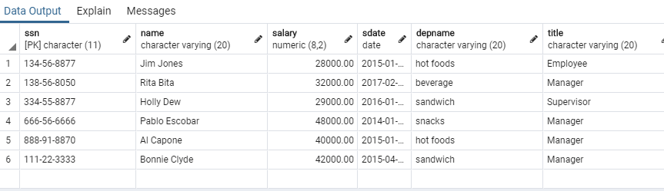

/* Replace original manager table with depmanager table */

DROP TABLE manager CASCADE;

/* depmanager table - mapping of department to manager */

CREATE TABLE depmanager (

depname varchar(20),

mssn char(11),

apdate date,

PRIMARY KEY (depname, mssn),

FOREIGN KEY (depname) REFERENCES department,

FOREIGN KEY (mssn) REFERENCES employee(ssn)

);

INSERT INTO depmanager (depname, mssn, apdate)

VALUES

('beverage', '138-56-8050', '03-18-2018'),

('snacks', '666-56-6666', '05-05-2015'),

('hot foods', '888-91-8870', '01-01-2016'),

('sandwich', '111-22-3333', '01-01-2016');

SELECT * FROM depmanager;

